**Overview of Project**

**Overview:** Overall, the analysis of global health expenditure data through Power BI provides valuable insights into the dynamics of healthcare spending, enabling stakeholders to make informed decisions and interventions to improve healthcare systems worldwide.

**Objective:** The objective of this Power BI project is to analysis global health expenditure data to gain valuable insights into various aspects of health spending across countries and regions. The primary goal is to provide a comprehensive and data-driven view of health expenditure trends, its relationships, and identify key patterns. The analysis aims to answer critical questions and support decision-making in the field of global healthcare.

**Key Insights:**

* Luxembourg is the country with the highest health expenditure for all years and the Democratic Republic of the Congo is the country with the lowest health expenditure for all years.
* The highest GDP percentage is of Monaco (22.22%).
* 2020 had the Maximum global health expenditure amount.
* Most countries spent total GDP below 100k and total expenditure below 40k.
* In 2020, Monaco and Luxembourg countries are almost close to each other compared to health expenditure. After that, there is a drastic drop in health expenditure in other countries. Monaco and Luxembourg have above 50k expenditure, as the higher the expenditure higher the GDP is observed.
* European countries spent higher total expenditure than Asian/African countries.
* Most of the countries spent more amount than the previous years and San Marino spent double the amount of the previous year's combined amount.
* Activate a Total of 573 countries participated and almost 23 million population spent expenditure amount 3.35 million and a GDP is 8.6 million.
* Report and Dashboard Creation: Developed a well-structured report with relevant visualizations and explanations, alongside an interactive dashboard for end-users to explore the data independently, facilitating data-driven decision-making in the field of global healthcare.

**Snapshot of Project**

**Data Exploration**

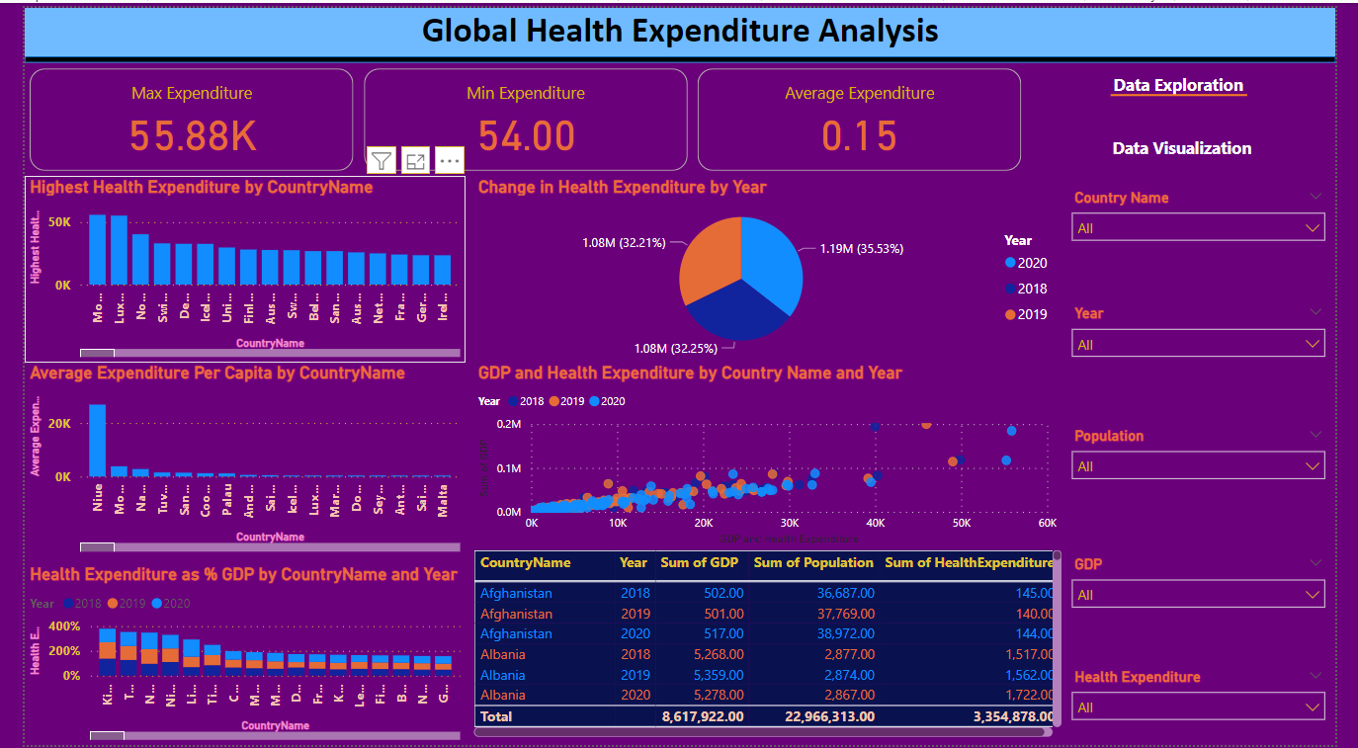

**Data Visualization**

